Technical Specification

King’s Lynn Corn Exchange

Tuesday Market Place
King’s Lynn
Norfolk, PE30 1JW

(01553) 765565


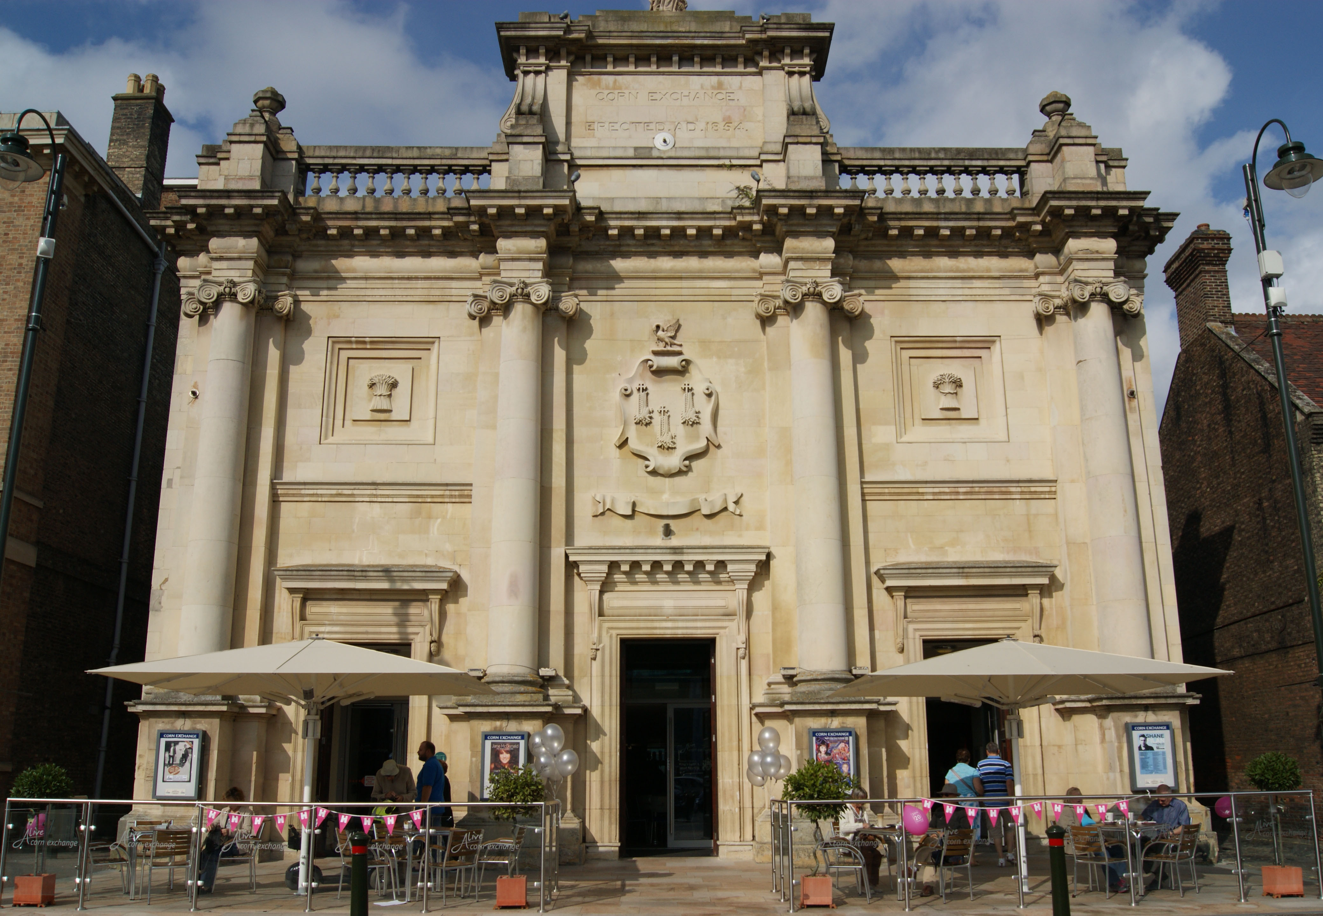

Contents

1
General Information

2
Load In & Access Information

3
Lighting Equipment

4
Sound Equipment

5
Communications

6
Miscellaneous

7
Power Supplies

8
Suspension Information, Stage Dimensions & Venue Plans

9
Accommodation

10
Local Information & Area Map

1

General Information

We advise that this Specification should be considered as being indicative of the equipment that may be available to users of the venue. However, specific equipment may not be available due to unforeseen circumstances, and all users of the venue should not assume that any piece of equipment is available without prior confirmation with the venues senior technical staff.

If there is any equipment that is not mentioned within this specification that may be specifically required for your event, please contact the Technical Manager prior to the event. We may be able to help.

Staff Contact Information

Corn Exchange Manager
Philip Bayfield. (01553) 765565.
philip.bayfield@alivemanagement.co.uk

Technical
James Heron Senior Technician (01553) 765565
Oliver Clark Maintenance Technician (01553) 765565

Technical Office
Scott Hunter (01553) 779103
Ashley Mayes (01553) 779103
Jason Elms (01553) 779103

Front of House

Mike Brown. FOH Manager (01553) 779100
Nicola Barker. FOH Manager (01553) 779100
Sarah Booth. Assistant FOH Manager (01553) 779100

Marketing
Nina McKenna. Director of Culture and Communication.(01553) 765565
Charlotte Wright. Head of Branding and Marketing. (01553) 779121
Sarah Dignam. Assistant Marketing Manager. (01553) 779116

Administration
Coral Cott Administration Manager. (01553) 765565

For all emails please use: firstname.lastname@aliveleisure.co.uk
For Example: coral.cott@aliveleisure.co.uk

Contact Information (Continued)

Website

www.kingslynncornexchange.co.uk

Social Media

@klcornexchange  Alive Corn Exchange

The Venue

King’s Lynn Corn Exchange
Tuesday Market Place
King’s Lynn
Norfolk
PE30 1JW

Venue Management: (01553) 765565
Box Office: (01553) 764864
Fax: (01553) 762141

2

Load In & Access Information

We strongly recommend that any large vehicles arrive and depart overnight, as access is made difficult by the public car park to the rear of the building.

(Be aware carpark around loading bay fills between 8am and 9am)

Load in is via a set of dedicated load-in door, which is approximately 5m from the stage. The dimensions are 2.13m(w) X 2.5m(h).

Parking is available for loading/unloading purposes at the rear of the venue. The loading bay area is marked with yellow hatching.

The use of the loading bay is by agreement with the venue technical staff and all users must obtain a permit from the technical staff on arrival.

Vehicles without a permit will be issued with and excess parking notice that the venue cannot be held accountable for.

Access Equipment

- 1 x Genie 1932 - Scissor Access Lift - IPAF Licence required to operate (All full time staff are licence holders)
- 1 x Set 14 rung Zarges A frame ladder
- 1 x Set 9 rung Zarges A frame ladder
- 1 x Set 4 rung Zarges A frame ladder

3

Lighting Equipment

Control Equipment

- ETC Ion DMX Lighting Console. Suitable for controlling both generic and moving fixtures. 40 Channel fader wing & touch screen monitor. (Latest Windows Motherboard update)

- Avolites Rolacue Pearl 2008 (Boris 3 with usb), DMX Lighting Desk. Suitable for controlling both generic and moving fixtures. Running 2010 software.

- ELC focus brain remote riggers linked directly to dimmers

- 114 ways of DMX controlled dimming for stage lighting. DMX Control of House Lights. House dimmers are currently preset for the fixed house rig. Please advise at least 30 days prior to your event of any changes or amendments that your event requires.

Lighting Equipment (Continued)

Channel Locations

- 36 channels red phase
- 42 channels yellow phase
- 36 channels blue phase

The above are hard wired at the dimmer end to the outlets on stage, Therefore no hard patching available. The dimmers allow a max loading of 2.5kw per channel on 10amp channels and 5kw on 25amp channels.

Socket Locations – (all are single circuits unless specified)

- FOH – 24 circuits at 10amps
6 circuits at 25amps
- Electrics Gallery, Upstage - 42 circuits at 10amps
6 circuits at 25amps
- Electrics Gallery, Downstage – 30 circuits at 10amps
- Dips - 8 circuits at 10amps

Total supply limit to dimmers – 150amps TPNE, (3 Phase)

Lanterns

- 58 x Par 64 Cans c/w CP62 lamps
- 4 x Par 64 Floor Cans c/w CP62 Lamps
- 4 x ETC 575w 26° Source four junior profiles
- 6 x ETC 575w Source four junior 22/50° zooms profiles
- 4 x ETC 750w Source 4 profiles
- 8 x Source 4 Zoom
- 10 x Strand Cantata Fresnels (some with barn doors)
- 3 x 6 way Cyc Floods
- 8 ADB Warp profiles 12degree-30degree.
- 6 x Mac Aura’s (Ext Mode)
- 4 x Standard Mac 250 Entour’s (Ext Mode)
- 12 x Chauvet Colourdash Quad 18 (10 Channel mode)
(8 on the bridges and 4 for stage floor)
- Standard Rig Plan is available on request.

Lighting Equipment (Continued)

Miscellaneous Lighting Equipment

- 2 Robert Juliet Victor 1800 Follow Spots with sights.
- Gel frames available for all lanterns
- Various Lengths 15A TRS
- 1x Mirror ball and rotator (1 speed)
- A Quantity of Irises for 575w profiles.
- Quantity assorted gobo’s
- Le Maitre MVS Hazer.

Lighting Rig Overview

- Standard rig colours are Lee Blue 119, Red 106, Amber 158, Mauve 126
- We also stock warms and colds
- The standard rig consists of a 4 colour Parcan wash over 3 trusses.
- 18x CP62 Pars each on LX 2 & 3, 12x CP62 Pars on LX 1 with 2x 1K Fresnels and 2x 575w S4’s centre of LX1.
- There are pairs of Source 4 Jr’s on pipe ends of LX 2 and 3 providing a cross stage gobo wash.
- FOH has 8 x 750w ADB Warp Zooms, CP62 Parcans on the side slip position (Paired across)
- 8x Chauvet Colour dash Quad 18 (10 Channel) LED’s, spread across the Bridge positions.
- A full rig of auditorium lighting is available for flat floor events.

Please note

Standard rig colours are Lee Blue 119, Red 106, Amber 158, Mauve 126 and warm and colds are stocked.

If any other colours are needed please inform us at least 2 weeks in advance.
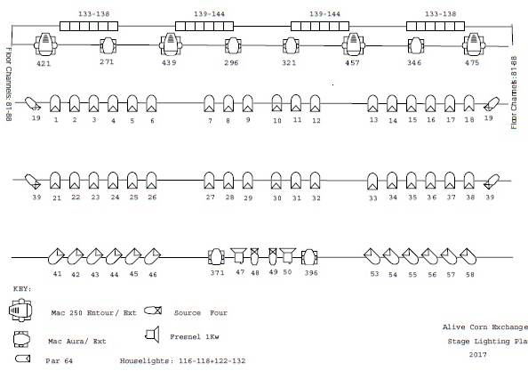

4

Sound Equipment

Touring Sound Position

The Front of House mix position is situated at the rear of the auditorium. Access for equipment is via a motorised hoist and travel track rated at loads of up to 500kg. All related lifting gear is available onsite.

Control Equipment

1x Yamaha CL-5

Amplification and Speakers

EV Line Array EVA-2082s/920 System
4x EV TX1122 (Delays and Cabaret setup)
2x EV ZX1 (Front Fills)
2x EV QRX218s (Subs)
4x Yamaha MS101
8x Yamaha 500w Wedges
2x HK Actor Tops
4x HK Actor Subs
6x JBL Control 1s

1x EV TG-7
1x EV TG-5
2x 1500 Crest Audio
1x 1100 Crest Audio
4x 650 Crest Audio

Sound Equipment (Continued)

Microphones

4x SM58
1x Beta SM58A
7x SM57
1x Beta SM57A
1x Sennheiser e906
1x Sennheiser e604
1x AKG D112
1x AKG C1000
3x Sennheiser MD-421
5x SE300b AKG
2x CK98 Capsule
2x CK91 Capsule
1x CK93 Capsule
3x Crown PCC Plate

Radio Microphones

8x Sennheiser G3 Series Receivers (Channel 38)
8x Sennheiser ew300 G3 Transmitter Packs (Channel 38)
2x Sennheiser ew300 G3 Hand Held Mics (Channel 38)

4x Sennheiser 100 G2 Series Receivers (Channel 70)
2x Sennheiser ew100 G2 Hand Held Mics
4x Sennheiser G2 Transmitter Packs (Channel 70)

Direct Injection (DI) boxes

2x BSS Audio AR-133 Active DI
4x Dual Di Boxes

Miscellaneous Equipment

4x 8way Loom Stage Boxes
Assorted XLR
2x Yamaha RIO 3216-d
1x Yamaha RO8-d

Assorted Speakon
Assorted BNC
2x Denon DN-501c CD Players
1x Ultralite MOTU Soundcard
2x Ipad

5

Communications

Altair master station capable of running a total of 8 out stations. Located in the control Room.

The system is linked using standard 3 pin XLR Microphone cable. Show relay is available in all Dressing Rooms, Green Room.

Show Calls can be made from the USR Wings and Control Room to all Dressing Rooms and Green Room.

6

Miscellaneous

Piano

- Grotrian Stienweg Concert Grand, (1996) available on stage and in Orchestra pit only.

Pianos can be tuned at the users advanced request and at the users expense. Only the theatre’s regular tuner is authorised to carry out tuning on the theatres piano. Tuning can only be conducted to A440.

Other Equipment

- 15x Doughty Orchestra Music Stands
- 1x Large Doughty Conductors Stand
- 5500 Lumens Projector c/w Laptop and DMX Shutter
- 4m x 3m Rear or Front Project Screen (Flown, or freestanding)

7

Temporary Power Supplies

Lighting Power

A Maximum 160A TPN is available in the USR dock through a combination of:

- 160amp TPNE Powerlock system. Located in Scene Dock.
- 125amp TPNE, (3 Phase) BS4343 cee-form socket. Located in Scene Dock.
- 2x 63amp TPNE, (3 Phase) BS4343 cee-form socket. Located in Scene Dock.
- 32amp TPNE, (3 Phase) BS4343 cee-form socket. Located in Scene Dock.

Sound Power

- 2x 63amp SPNE, (Single Phase) BS4343 cee-form Socket. Located in Scene Dock
- 63amp SPNE, (Single Phase) BS4343 cee-form Socket. Located Up Stage Left
- 16amp SPNE, (Single Phase) BS4343 cee-form socket. Located outside control Room.
- Several 13amp Sockets located around the Stage Area and in Orchestra Pit. All individually RCD Protected

Green room Power

- 32amp Single phase

8

Suspension Information, Stage Dimensions & Venue Plans

Flying System

- 6 Motorised flying bars to a maximum SWL of 250kg
- 3 Hemp flying bars to a maximum SWL of 100kg

Rigging

- Maximum SWL available upon request.

Staging Dimensions

Full Size Stage: is 12m (w) x 8.4m (d) (Seating Capacity 703 incl 7 wheelchairs)
Extended Stage: is 12m (w) x 10.5m (d) (Reduced Capacity 646 incl 7 wheelchairs)
FOH Mix Position: takes up 24 seats

Risers

- Quantity of modular risers measuring 750mm x 750mm at heights of 250mm, 500mm & 750mm

Orchestra Pit

The pit is made of a 12.0m (w) x 2.50m (d) moving section of the auditorium floor. The maximum pit size is 12.0m (w) x 2.5m (d).

Additional space can be gained by using part of the sub stage store, thought this limits flexibility with the depth of the pit.

Conditions of use: Users must ensure that 2 routes of access/egress are left completely clear.

The use of the Orchestra Pit reduces the audience seating capacity by 57 seats.

9

Accommodation

Dressing rooms

- 1 Star dressing room to accommodate 4, located at stage level.

- 2 Small dressing rooms to accommodate 6, located on 1st Floor

- 2 Large dressing Rooms to accommodate 15, located on 1st Floor.

Shower facilities available in all dressing rooms, (Star dressing room also has en-suite toilet).

2 large clothes rails for dressing rooms or on stage.

Please enquire about disabled access and facilities backstage.

- 1 Large Green room, which can be used for catering however all LPG or similar flammable gases/liquids must be removed before the house opens.

Production Office

There are no production office facilities available.
We recommend the use of a spare dressing room.

10

Local information & Area Map

For information on local accommodation and restaurants, please contact King’s Lynn Tourist Information on (01553) 763044

(Be aware carpark around loading bay fills between 8am and 9am Lorries should arrive early to park)

Area Map
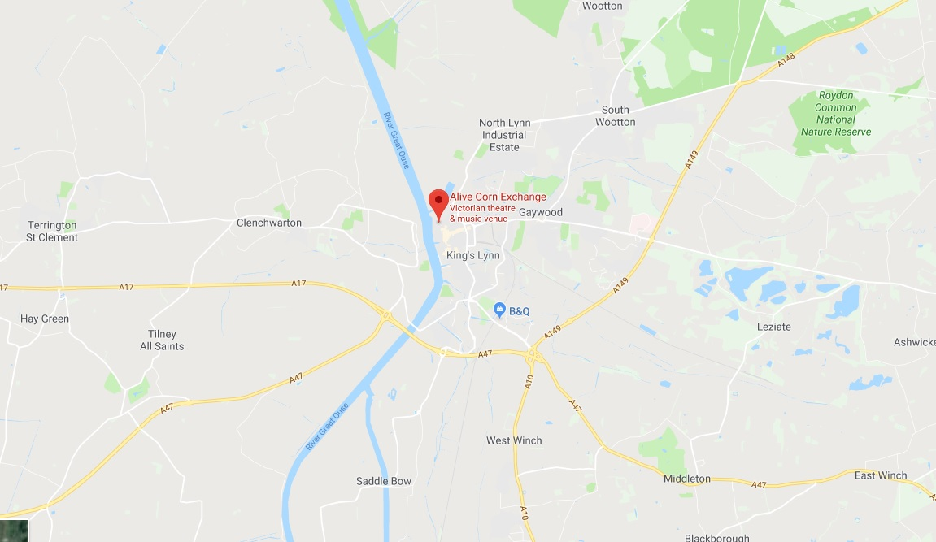

Local information & Area Map

(Be aware carpark around loading bay fills between 8am and 9am Lorries should arrive early to park)

Articulated Lorries should use the rear entrance of the carpark.



